TESTING EVIDENCE DOCUMENT-ASSESSMENT 2

# AudioTrack Unit Tests

Test Case 1-PASSED (As allows the AudioTrack testTrack to be instanced)



Test Case 2-PASSED

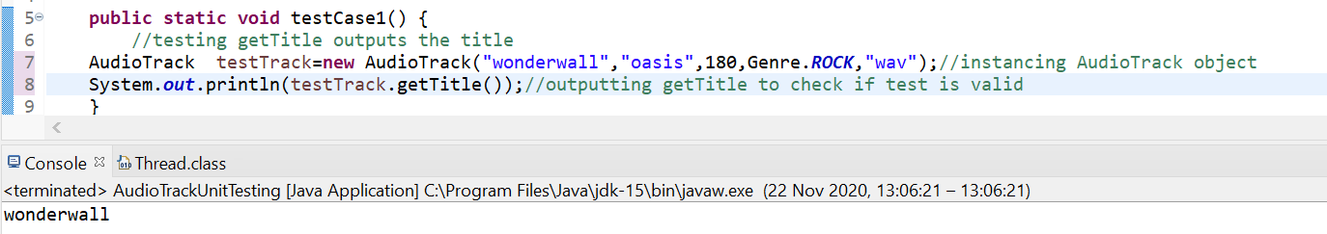

Test Case 3-PASSED

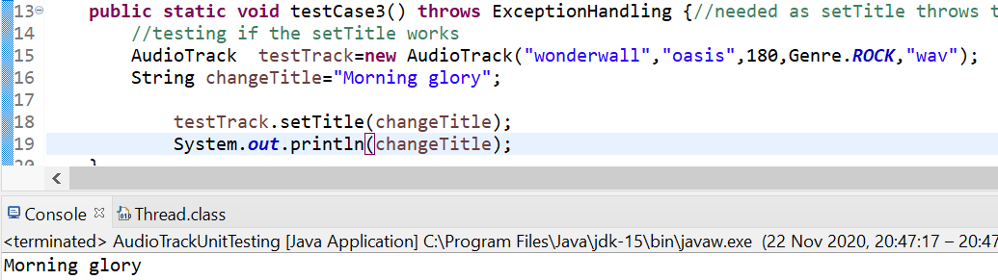Test Case 4-Passed

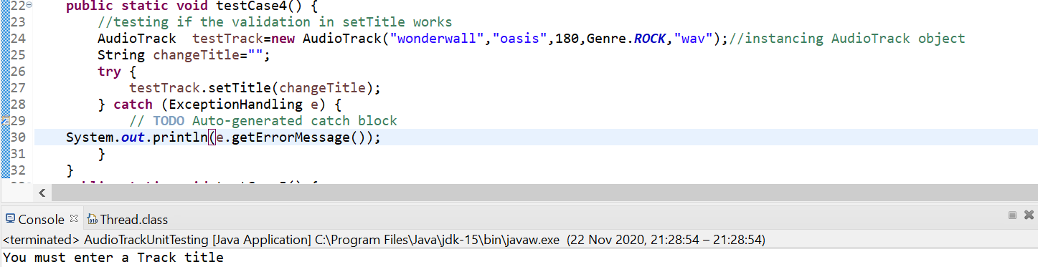

Test Case 5-Failed

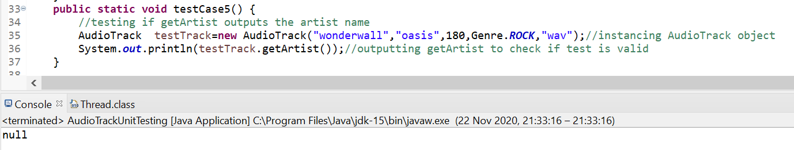

Failed Corrections

It was wrong because it was instanced the word way around.

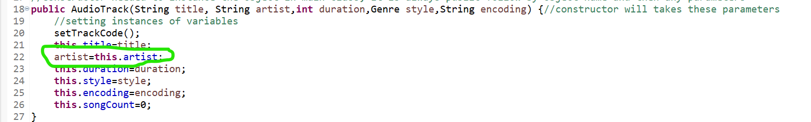

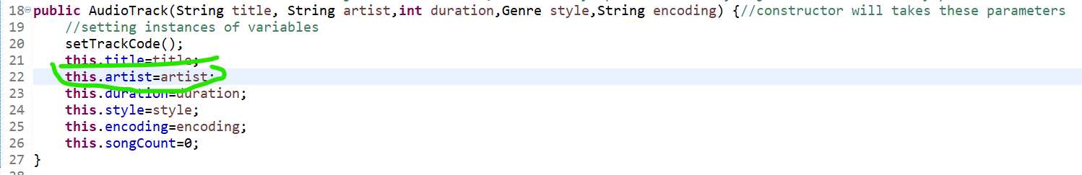

IT IS NOW FIXED

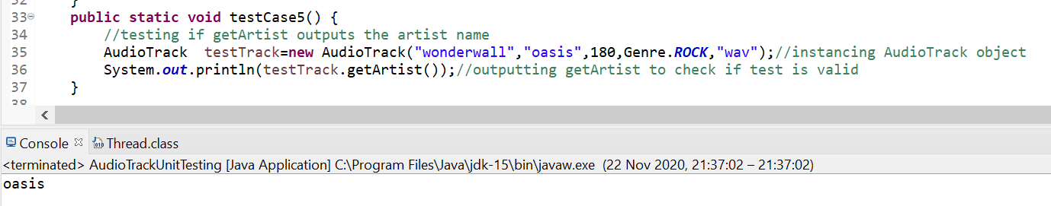

Test Case 6-Passed

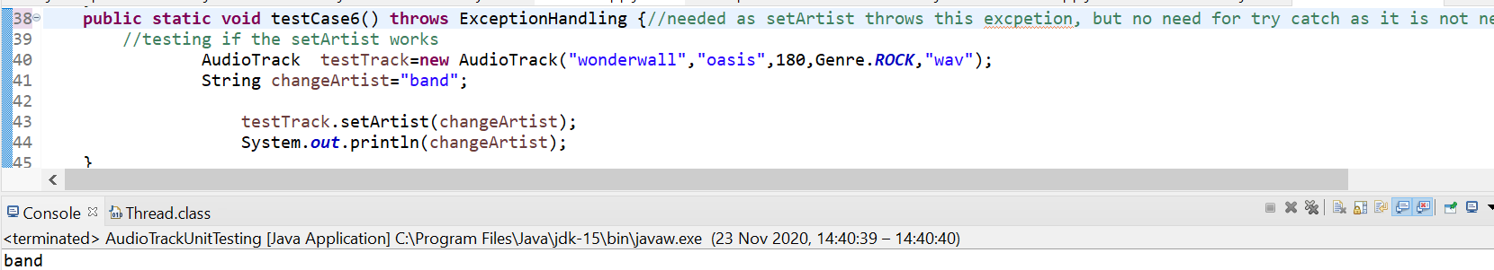

Test Case 7-Passed

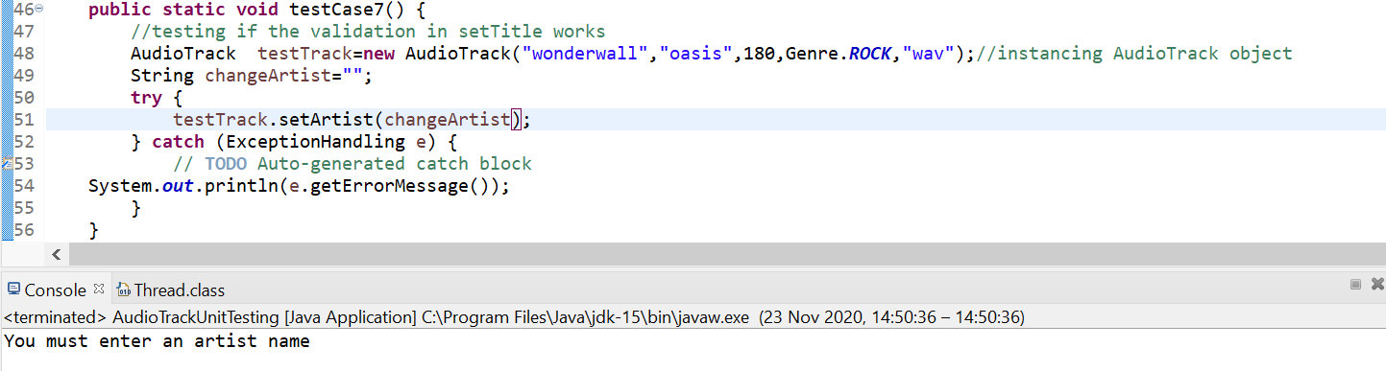

Test Case 8-Passed

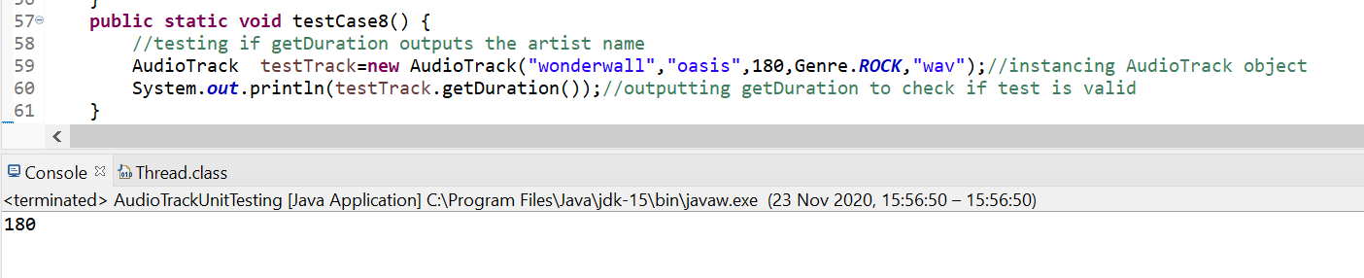

Test Case 9-Passed

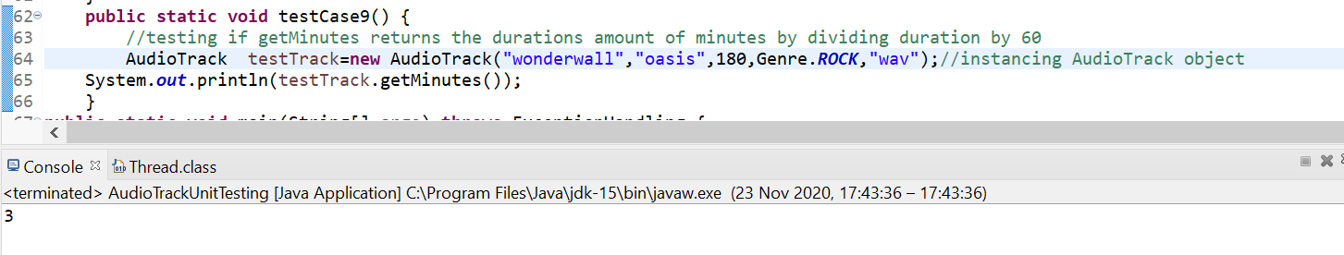

Test Case 10-Passed

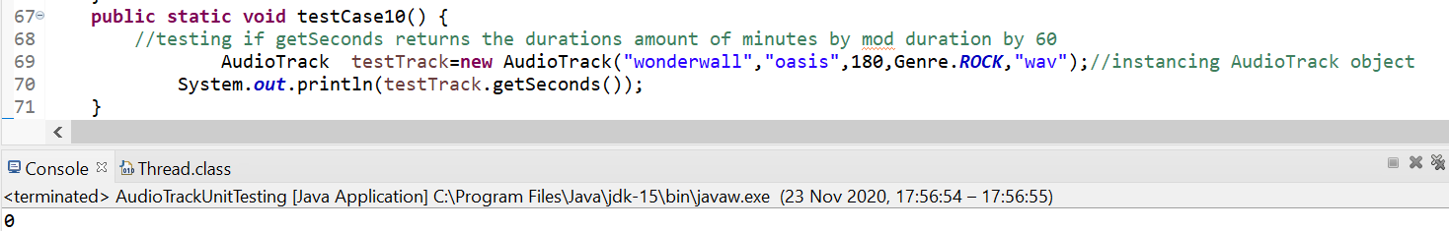

Test Case 11-Passed

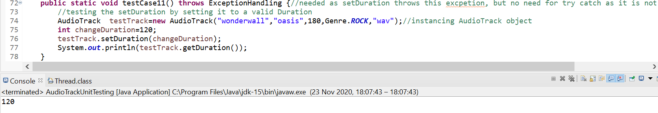

Test Case 12-Passed

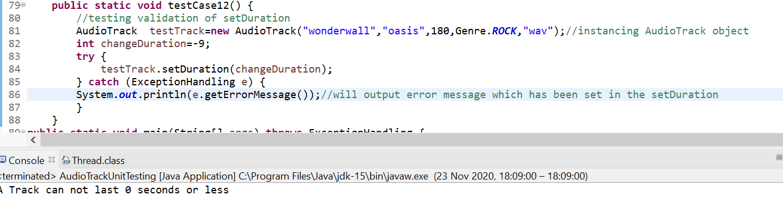

Test Case 13-Passed

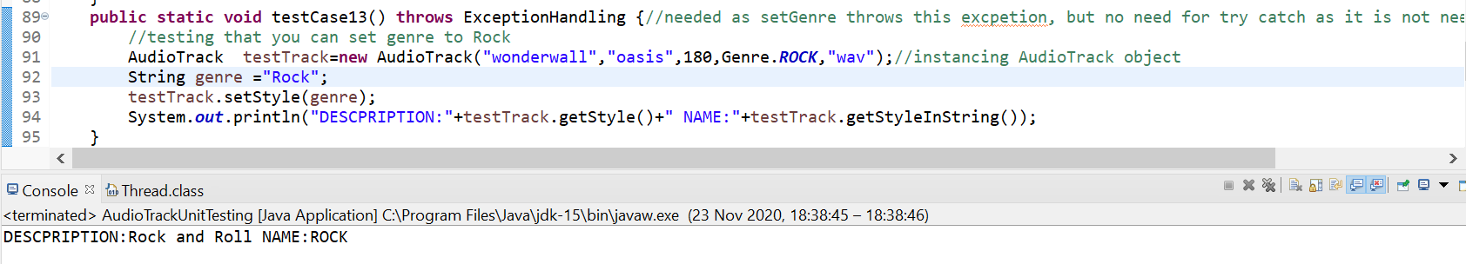

Test Case 14-Passed

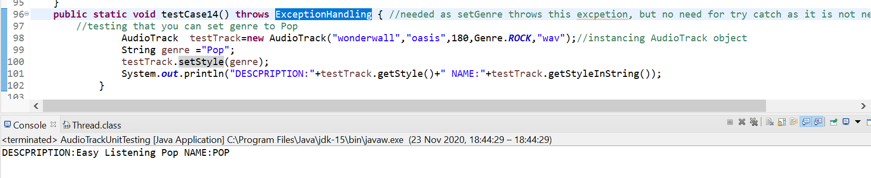

Test Case 15-Passed

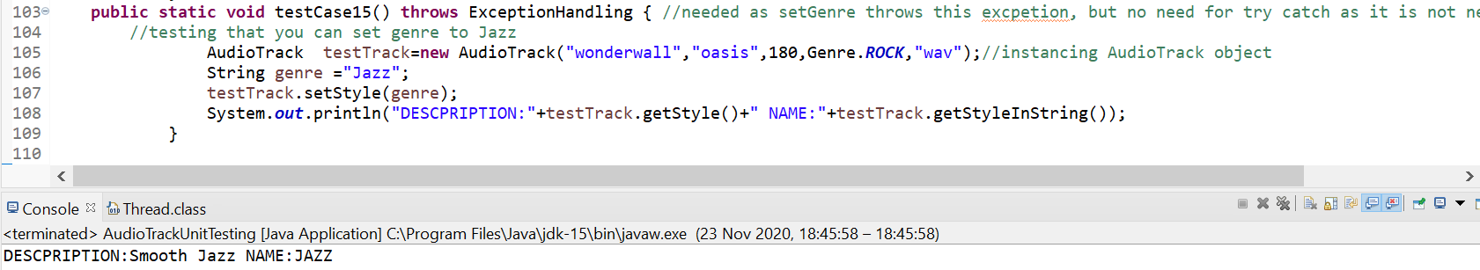

Test Case 16-Passed

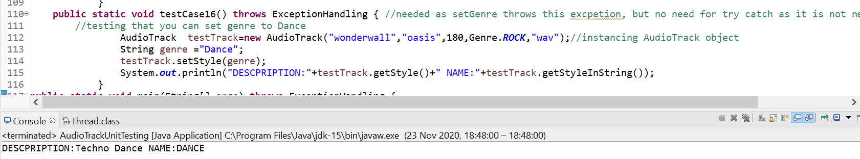

Test Case 17-Passed

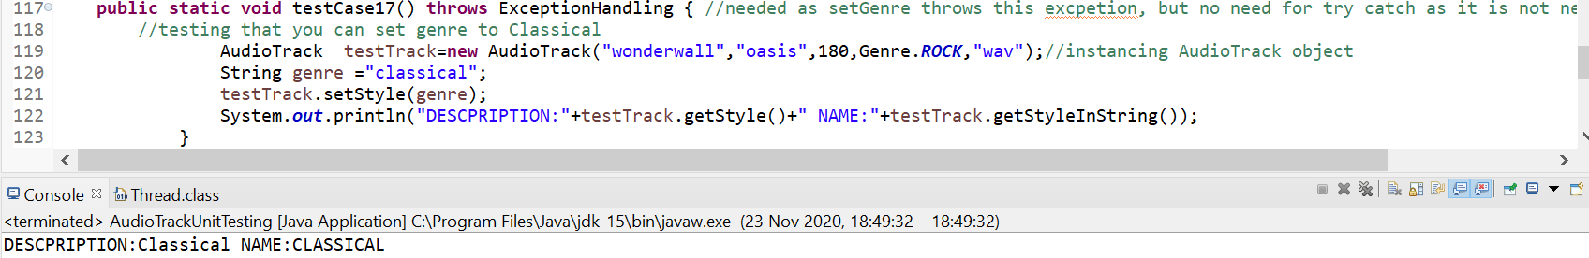

Test Case 18-Passed

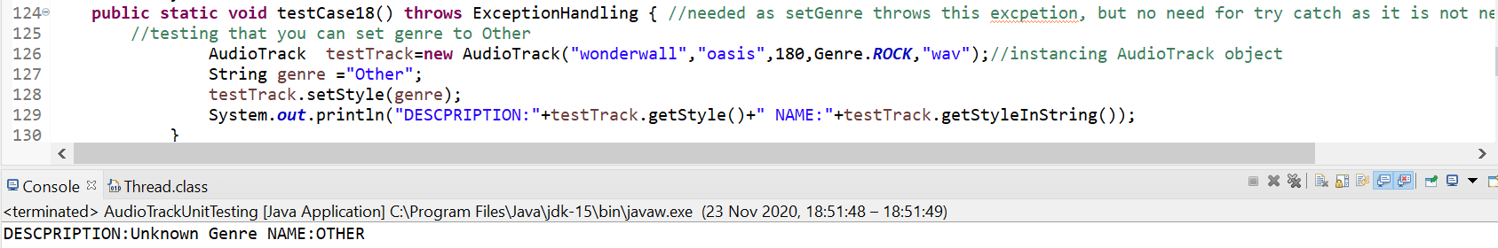

Test Case 19-Passed

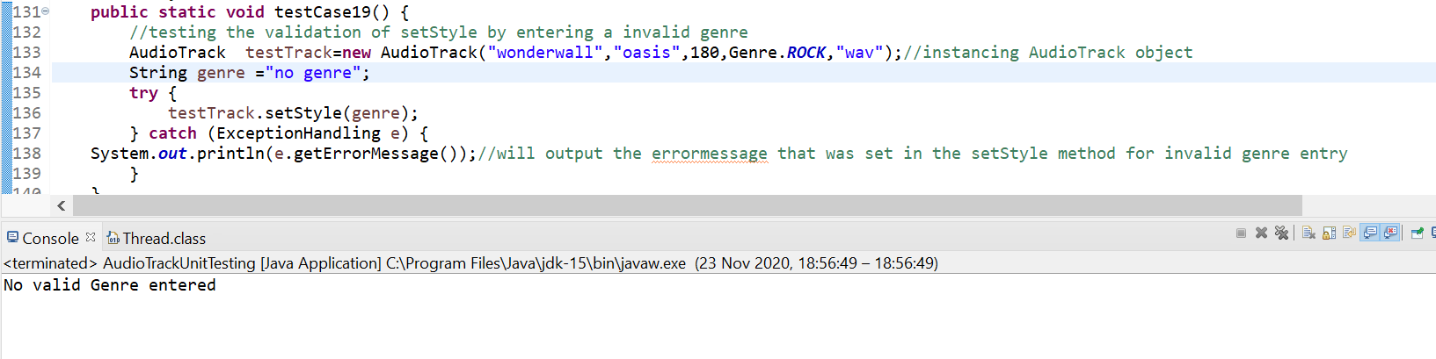

Test Case 20-Passed

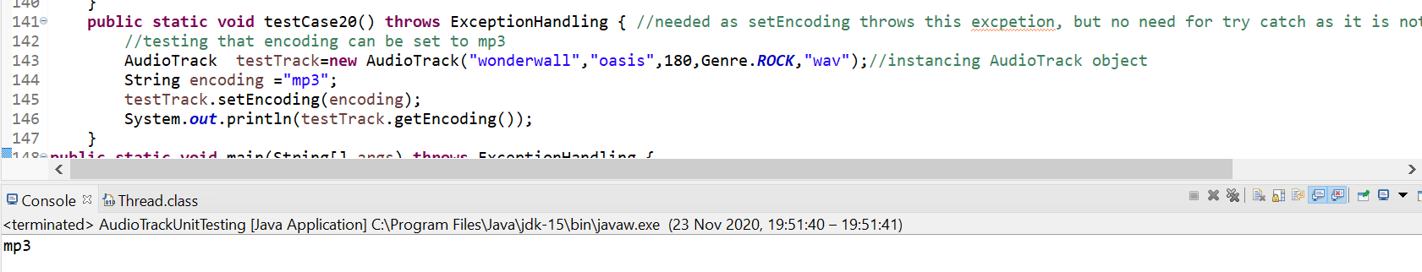

Test case 21-Passed

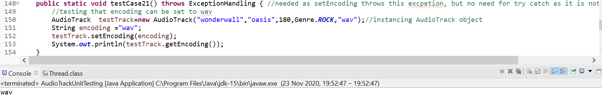

Test Case 22-Passed

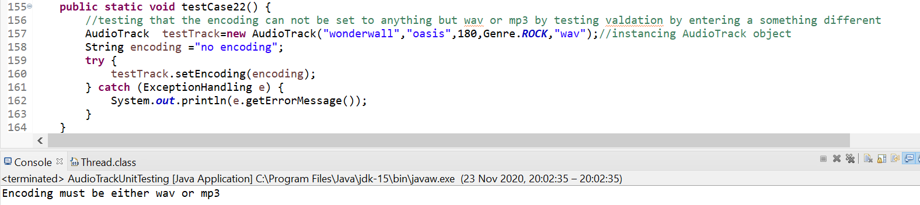

Test Case 23-Passed

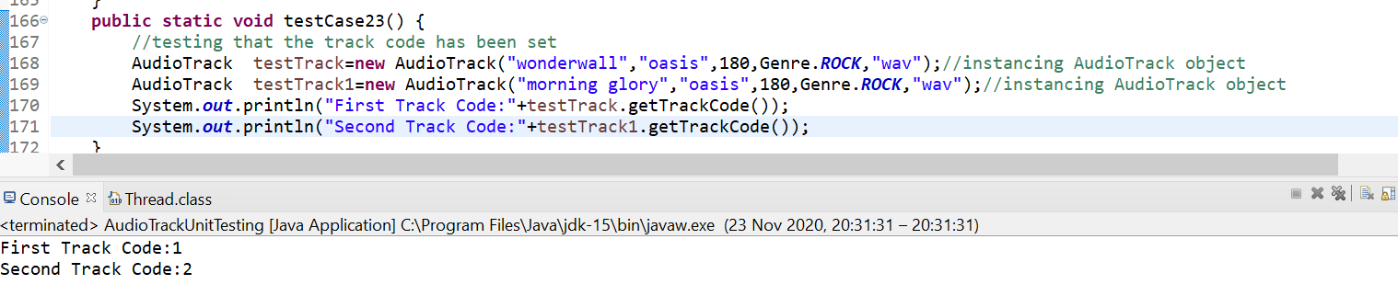

Test Case 24-Passed

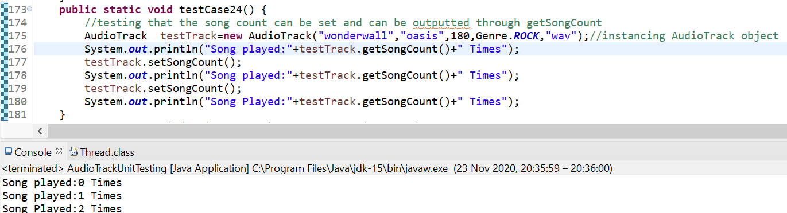

Test Case 25-Failed- doesn’t be in time format with only 0 and not 00

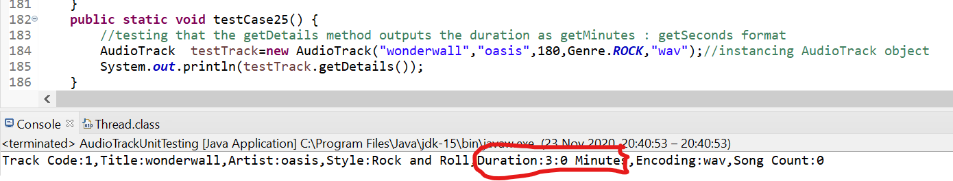

Test Case 26-Passed

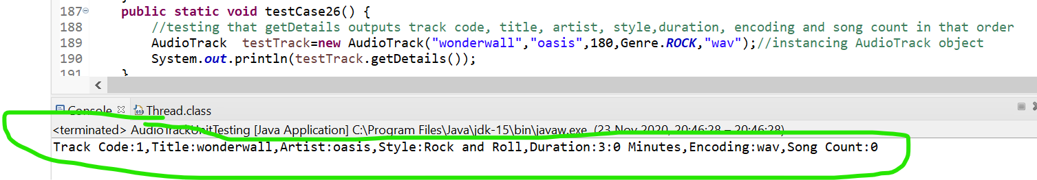

# AudioPlayer Unit Tests

Test Case 27-Passed



Test Case 28-Passed

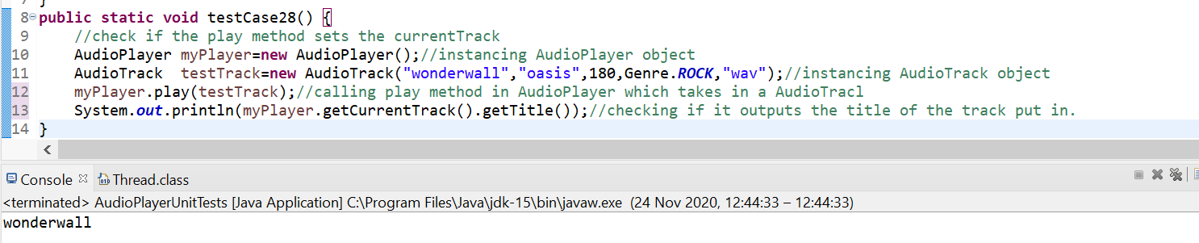

Test Case 29-Passed

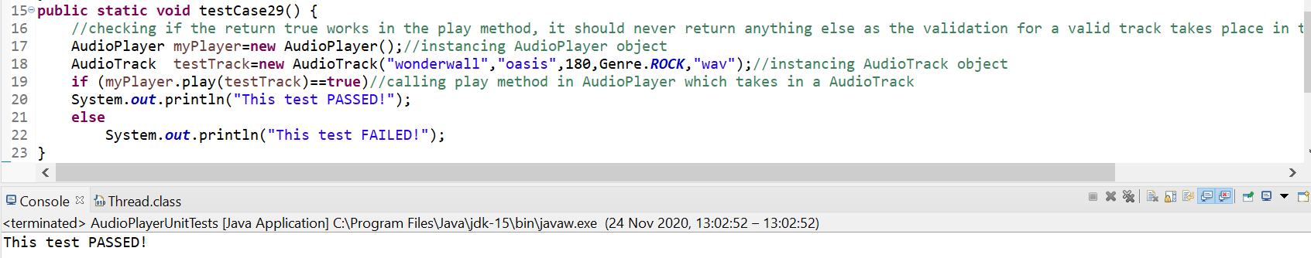

# Jukebox Integration Testing

Test Case 30-Passed



Test Case 31-Passed

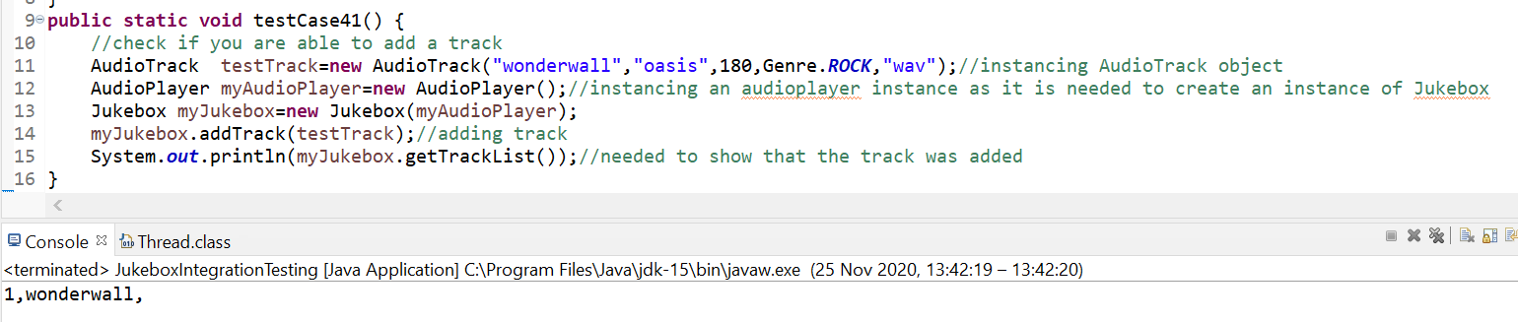

Test Case 32-Passed

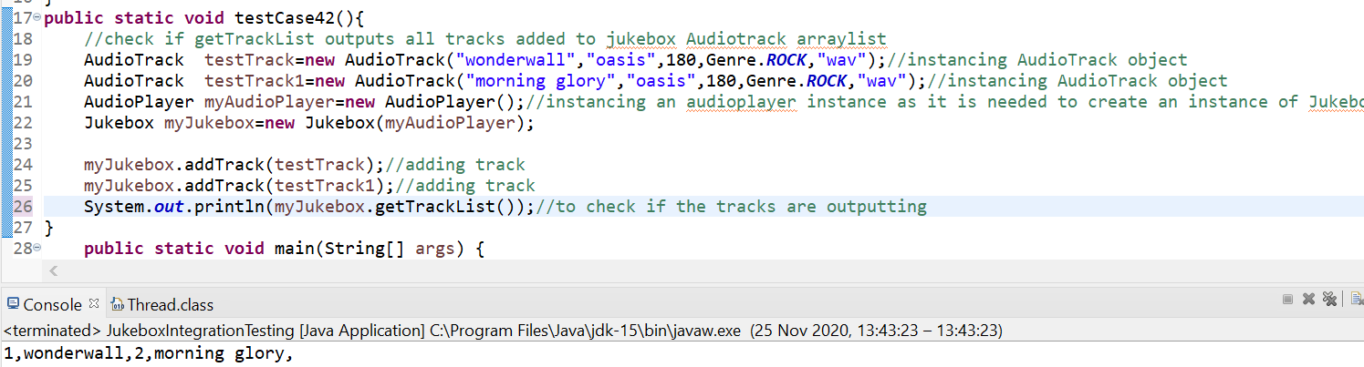

Test Case 33-Passed

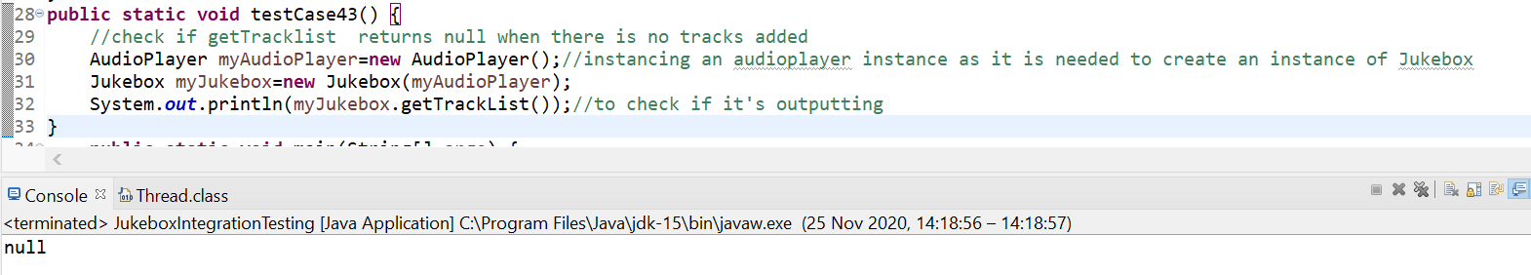

Test Case 34-Passed

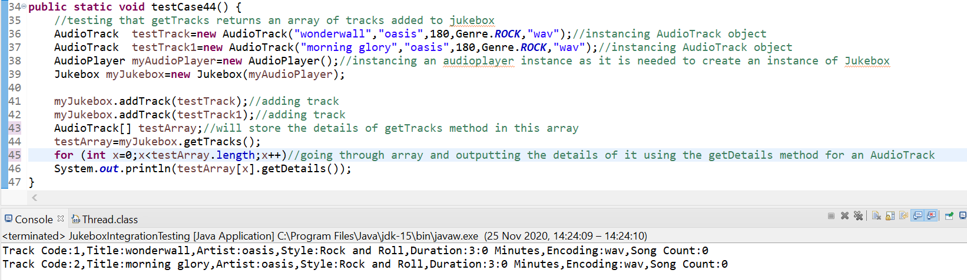

Test Case 35-Passed

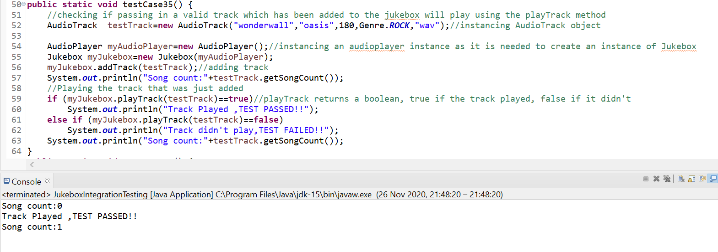

Test Case 36-Passed

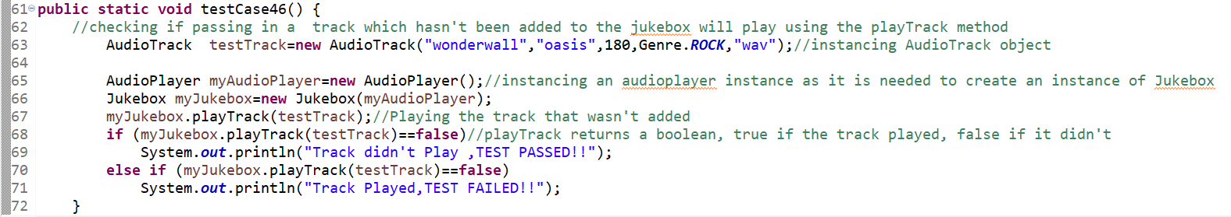

Test Case 37-Passed

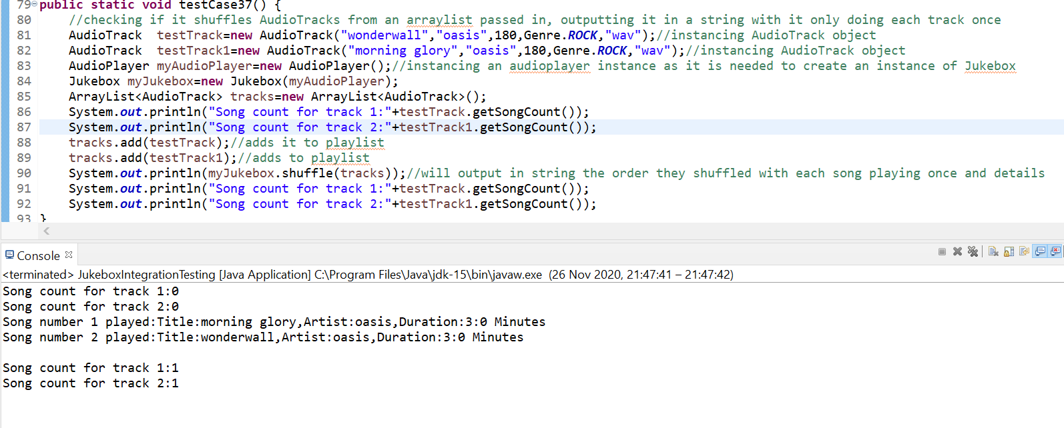

**AudioApp (Console App) System testing**

Test Case 38-Passed

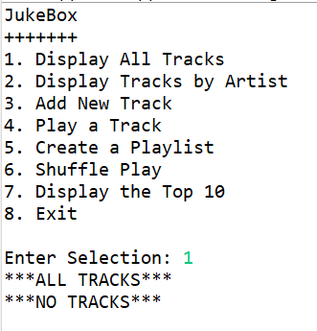

Test Case 39-Passed



Test Case 40-Passed

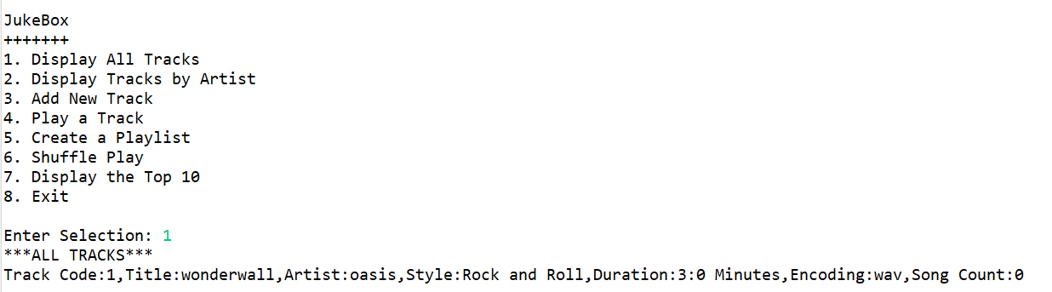

Test Case 41-Passed

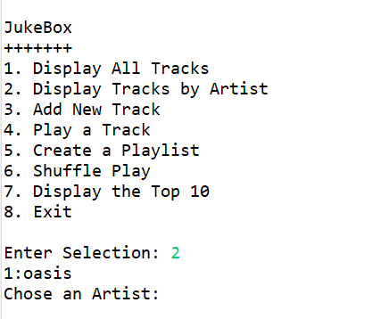

Test Case 42-Passed

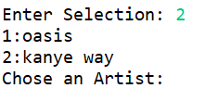

Test Case 43-Passed

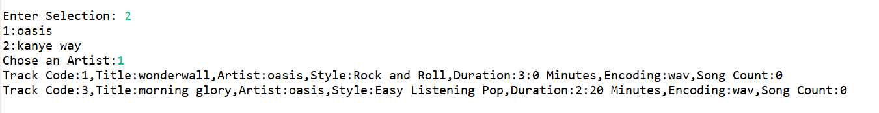

Test Case 44-Passed

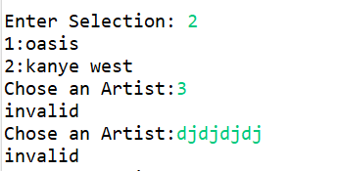

Test Case 45-Passed

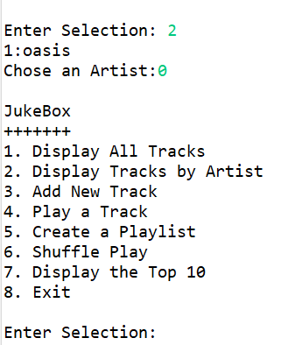

Test Case 46-Failed

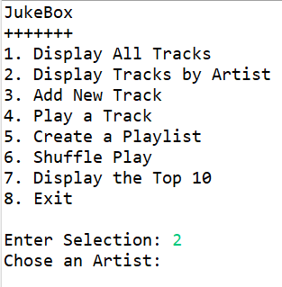

After error was fixed

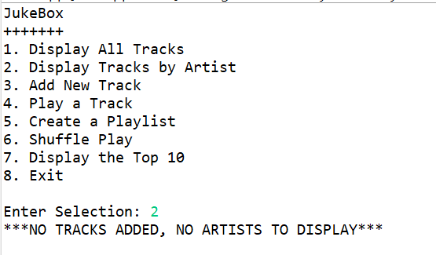

Test Case 47-Passed

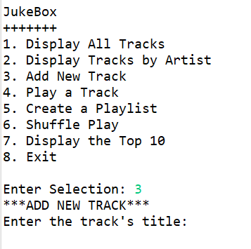

Test Case 48-Passed

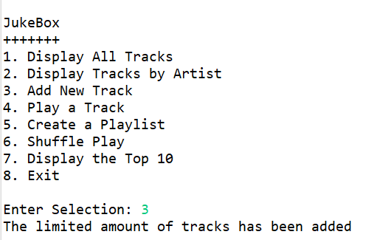

Test Case 49-Passed

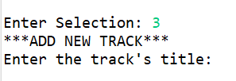

Test Case 50-Passed

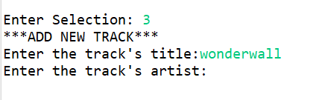

Test Case 51-Passed

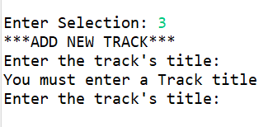

Test Case 52-Passed

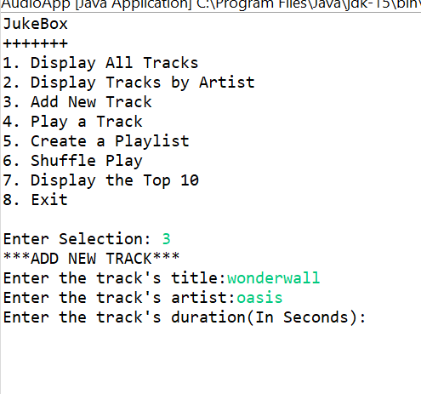

Test Case 53-Passed

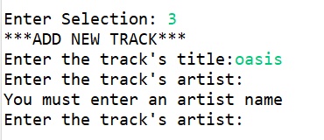

Test Case 54-Passed

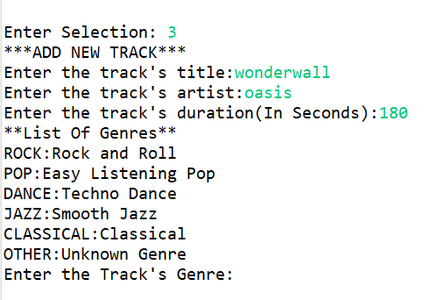

Test Case 55-Passed

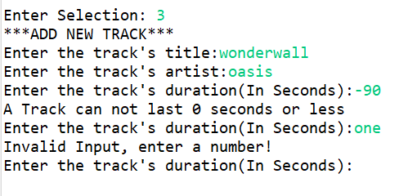

Test Case 56-Passed

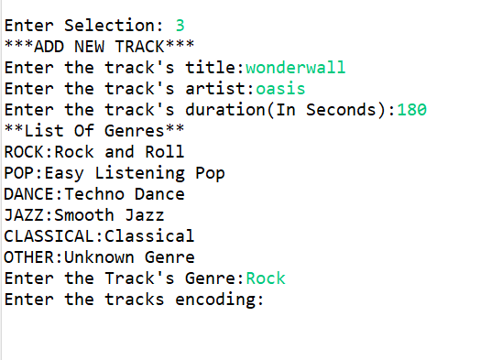

Test Case 57-Passed

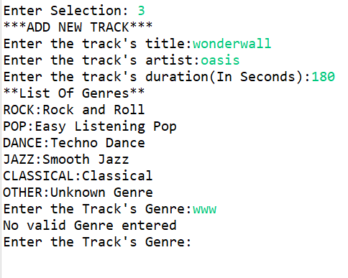

Test Case 58-Passed

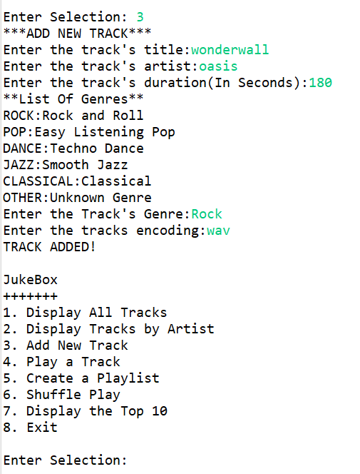

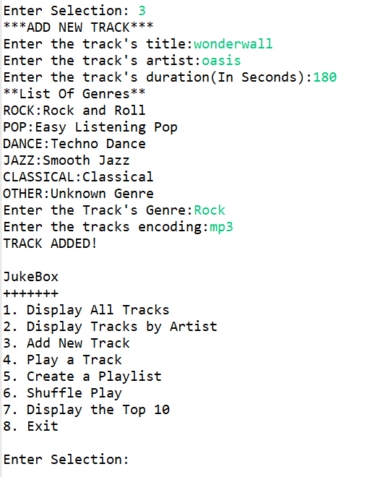

Test Case 59-Passed

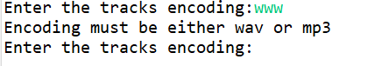

Test Case 60-Passed

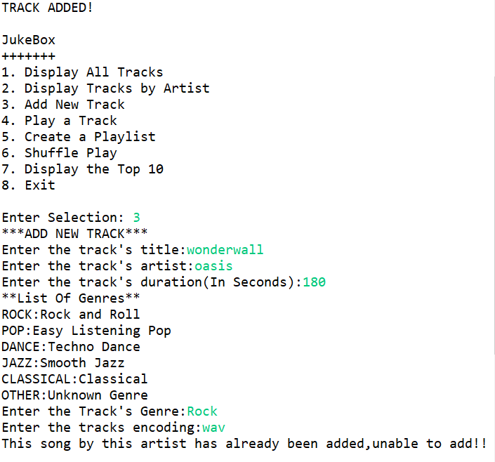

Test Case 61-Passed

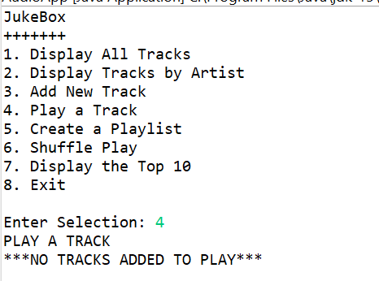

Test Case 62-Passed



Test Case 63-Passed

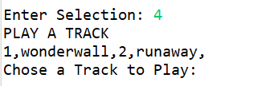

Test Case 64-Passed

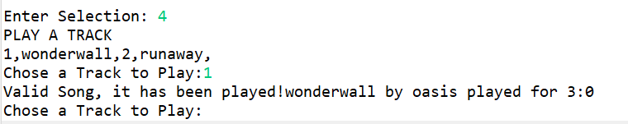

Test Case 65-Passed

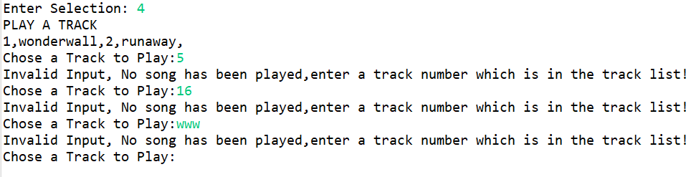

Test Case 66-Passed

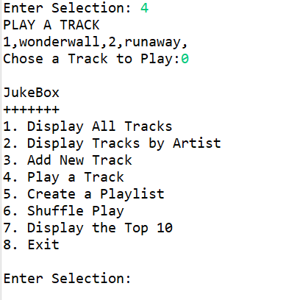

Test Case 67-Passed

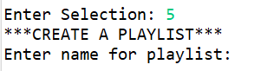

Test Case 68-Passed

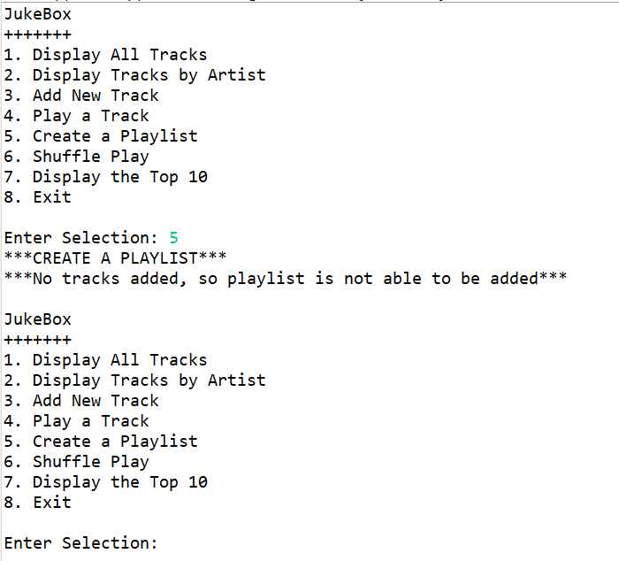

Test Case 69-Passed



Test Case 70-Passed

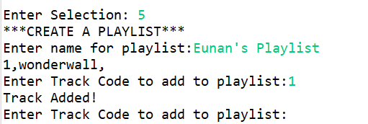

Test Case 71-Passed

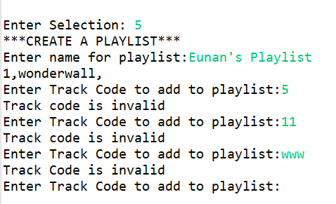

Test Case 72-Passed

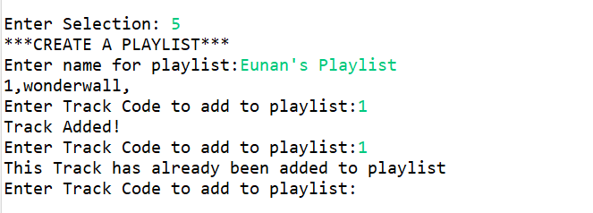

Test Case 73-Passed

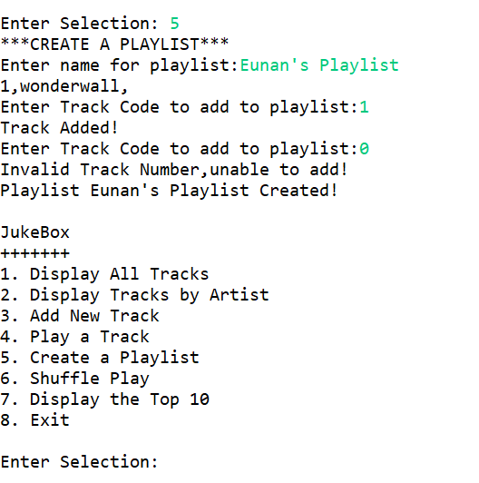

Test Case 74-Passed

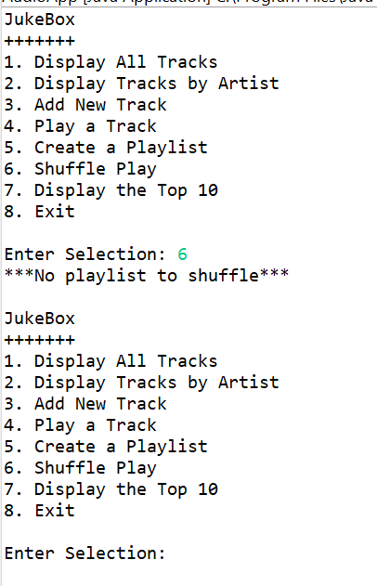

Test case 75-Passed



Test Case 76-Passed

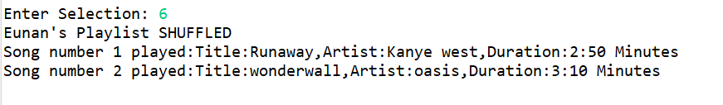

Test Case 77-Passed

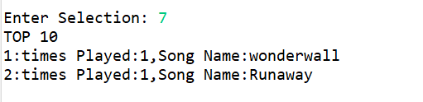

Test Case 78-Passed



Test Case 79-Passed

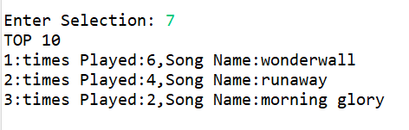

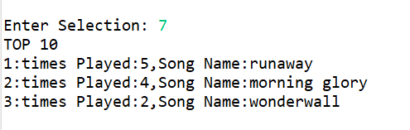

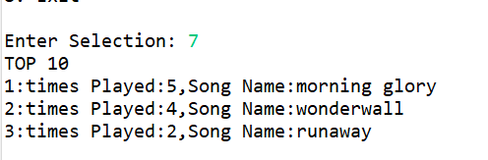

Test Case 80-Passed

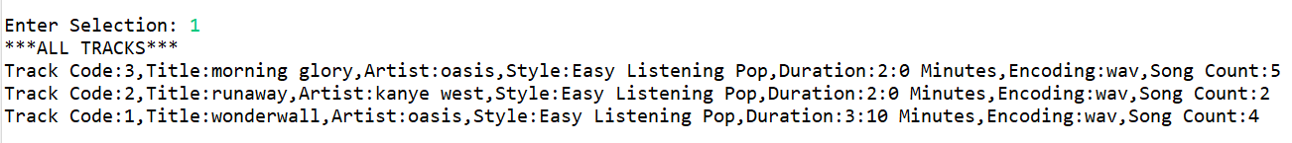

Test Case 81-Passed

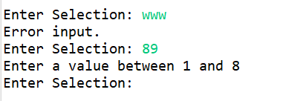

Test Case 82-Passed

